Using HTML, practically generate the output in (a, & b). Note: Pay keen attention to the details stipulated in the diagrams.

1. ***(10 marks)***

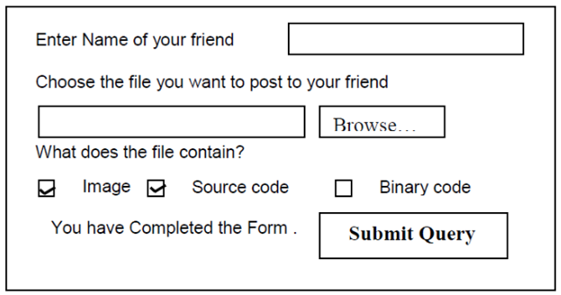

1. Note: other diagrams show details that should be represented in code. ***(10 marks)***

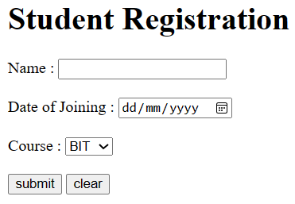 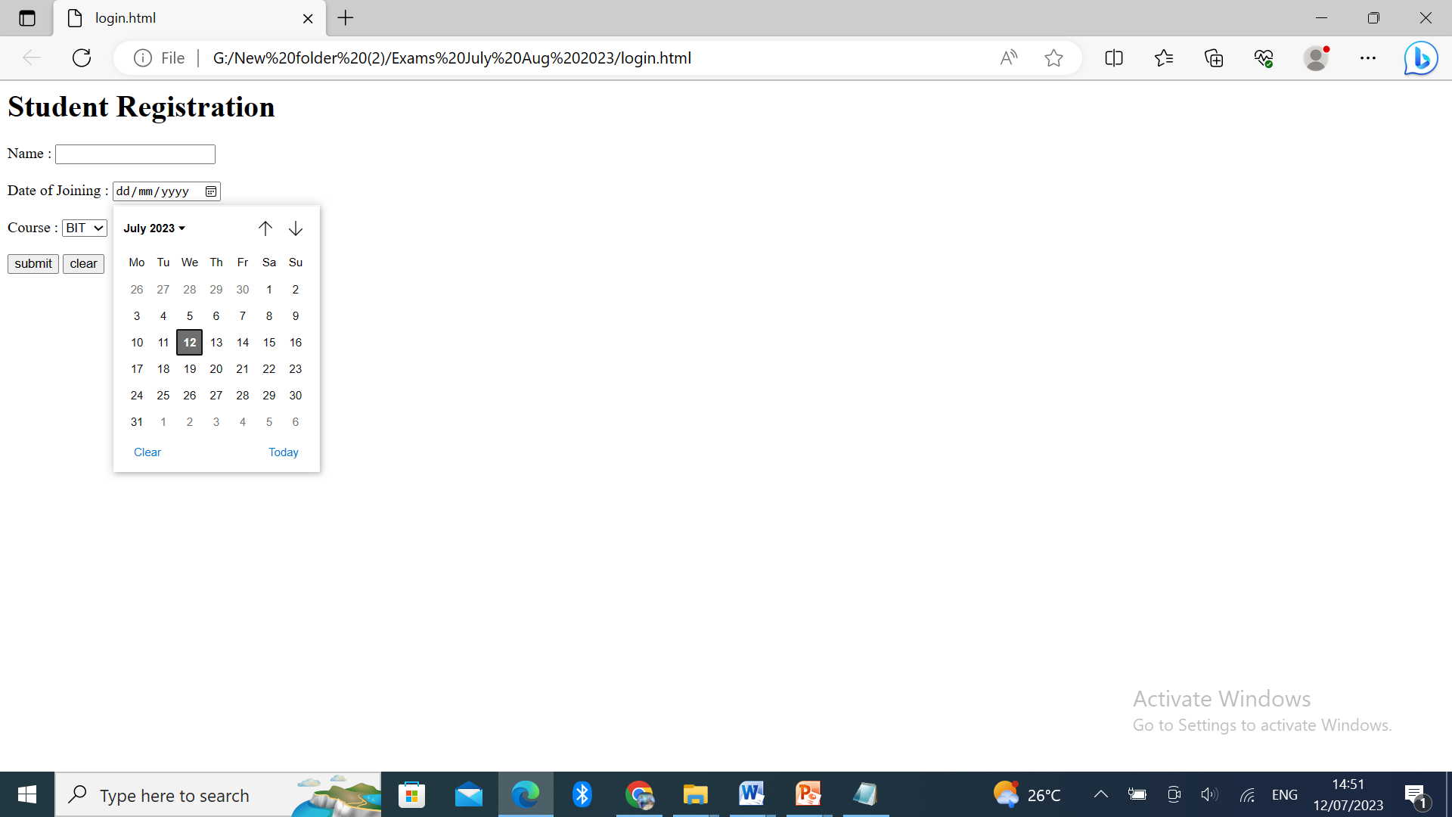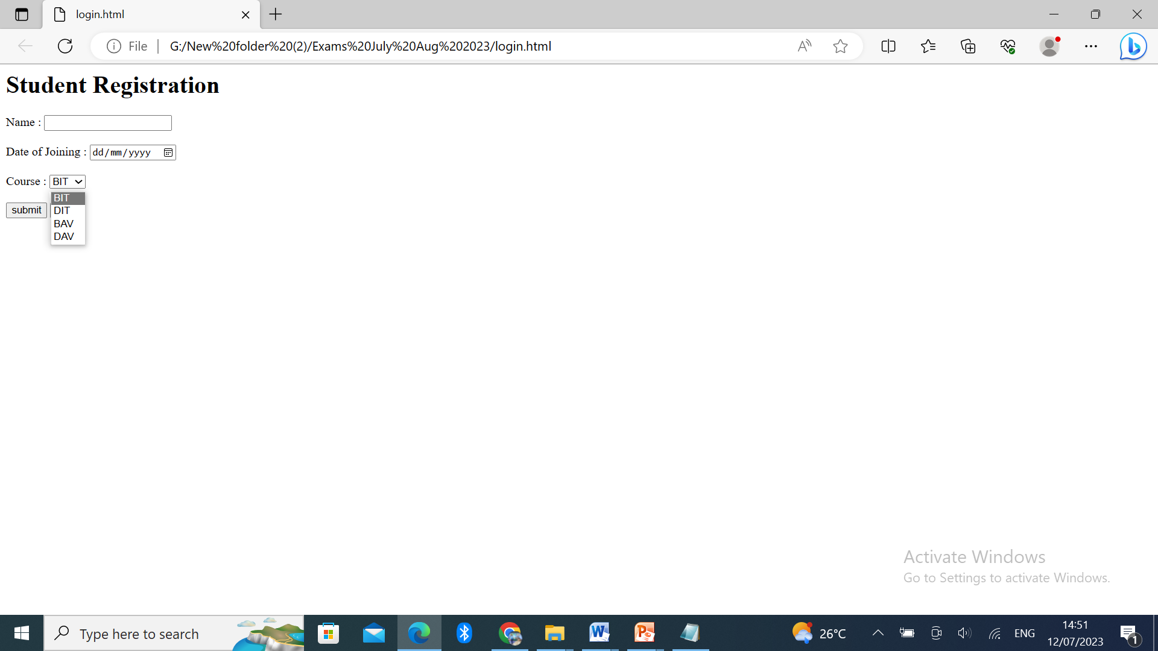

1. Design a webpage that will output the following form contents (9 marks)

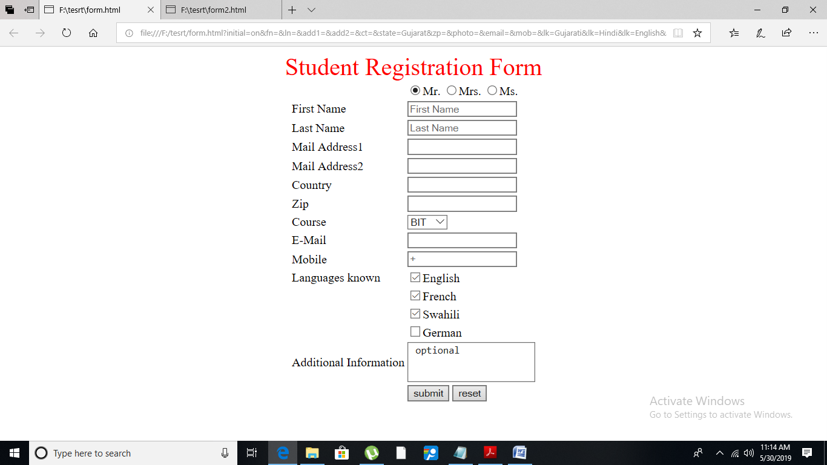

**Note**:

1. The whole content of the webpage is in the center
2. The font size of the text Student registration form is “6” and its color is red,
3. The contents of the form are incorporated into the table
4. The options under course include; BIT, BCS, BIS, and DIT in that order
5. There are no table boarders defined as shown in the figure.